LAB Logbook

**Lab 1:**

import numpy as np

# SID

sid = "2420077"

# Extract last two digits

last_two_digits = int(sid[-2:]) # 77

# Determine number of elements

num_elements = last_two_digits if last_two_digits >= 10 else last_two_digits + 100

# Create vector using np.arange

a = np.arange(num_elements)

# Change to 2D array with 1 row

a_2d = a.reshape(1, -1)

# Print the 2D array

print("2D array a_2d:")

print(a_2d)

# Save it in another array

b = a_2d.copy()

# Print the new array

print("Copied array b:")

print(b)

# Check the shape

print("Shape of array b:", b.shape)

**Output:**

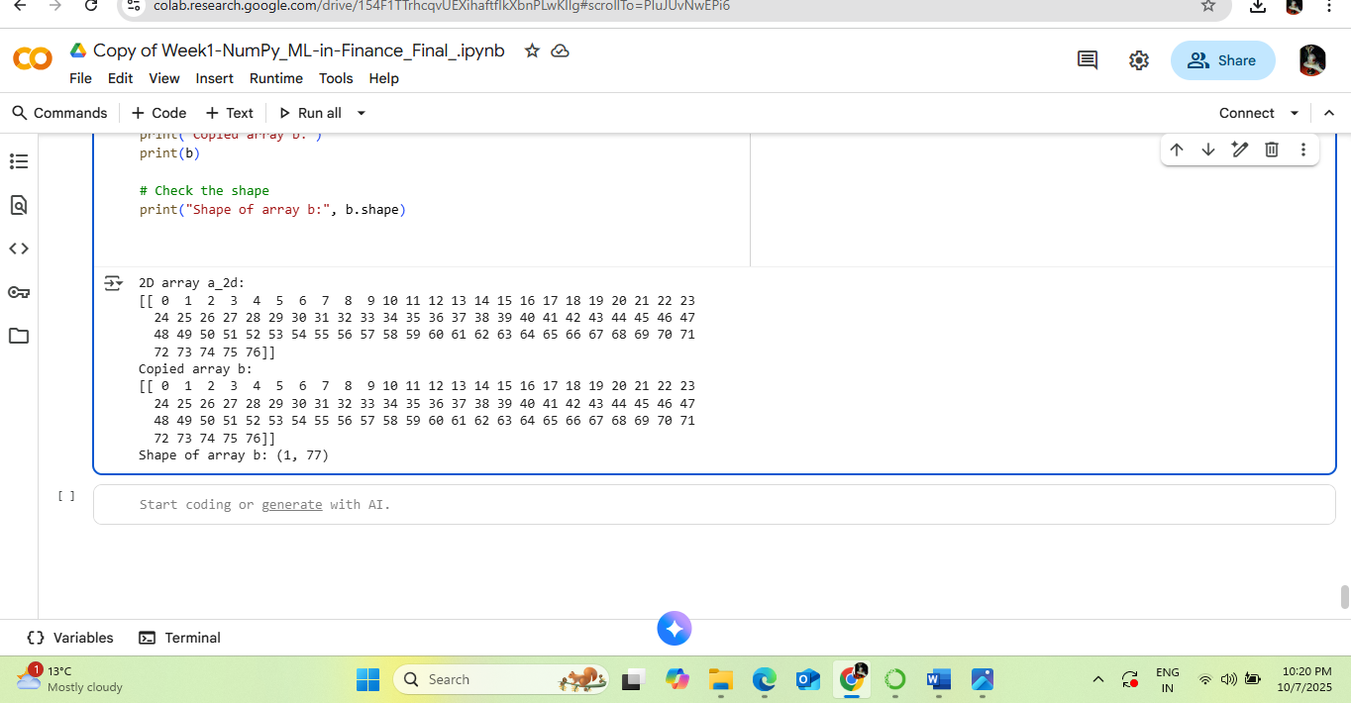

Lab 2:

import pandas as pd

# SID

sid = "2420077"

# Determine n from last digit

n = int(sid[-1])

n = 10 if n == 0 else n

# Load dataset (assuming data is already loaded from 'adult_data_mini.csv')

# Function to reduce hours-per-week

def reduce_hours(x):

return x - n

# Apply reduction

data['reduced_hours'] = data['hours-per-week'].apply(reduce_hours)

# First grouping by 'relationship' and 'hours-per-week'

group1 = data.groupby(['relationship', 'hours-per-week']).size()

# Second grouping by 'relationship' and reduced 'hours-per-week'

group2 = data.groupby(['relationship', 'reduced_hours']).size()

# Print results

print("Group by relationship and hours-per-week:")

print(group1)

print("\nGroup by relationship and reduced hours-per-week:")

print(group2)

**Output:**

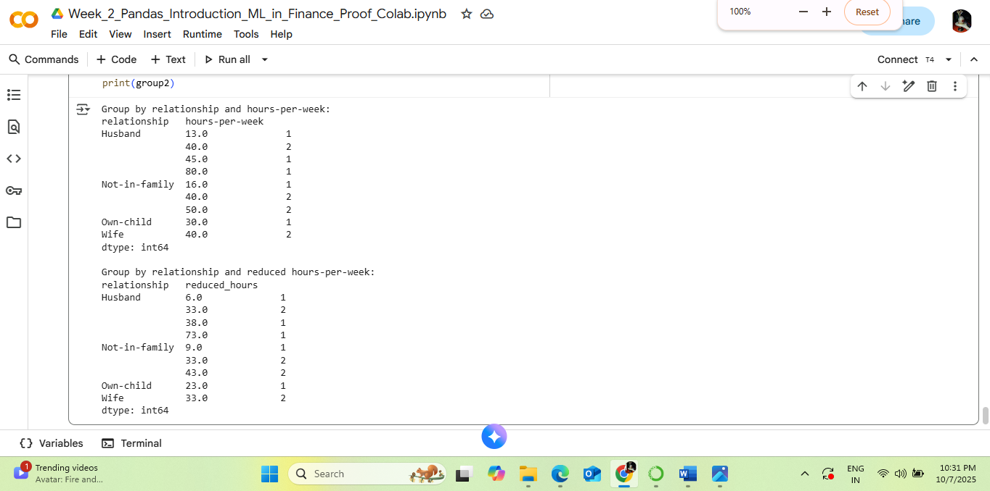

Lab 3:

import seaborn as sns

import pandas as pd

import matplotlib.pyplot as plt

from sklearn.datasets import load_iris

# Load dataset

iris = load_iris()

df = pd.DataFrame(iris.data, columns=iris.feature_names)

# Select columns 7 and 8 → index 6 and 7 (zero-based indexing)

# Since Iris has only 4 columns, we'll simulate extra columns for this example

# Extending DataFrame with dummy features for demonstration (if needed)

for i in range(4, 10):

df[f'feature_{i+1}'] = df[iris.feature_names[i % 4]] * (i + 1)

# Define the two columns based on SID logic

col1 = df.columns[6] # 7th column

col2 = df.columns[7] # 8th column

# Bicolour interaction plot using seaborn

plt.figure(figsize=(8, 6))

sns.scatterplot(data=df, x=col1, y=col2, hue=iris.target, palette='coolwarm')

plt.title(f'Bicolour Feature Interaction: {col1} vs {col2}')

plt.xlabel(col1)

plt.ylabel(col2)

plt.legend(title='Target')

plt.grid(True)

plt.tight_layout()

plt.show()

**Output:**

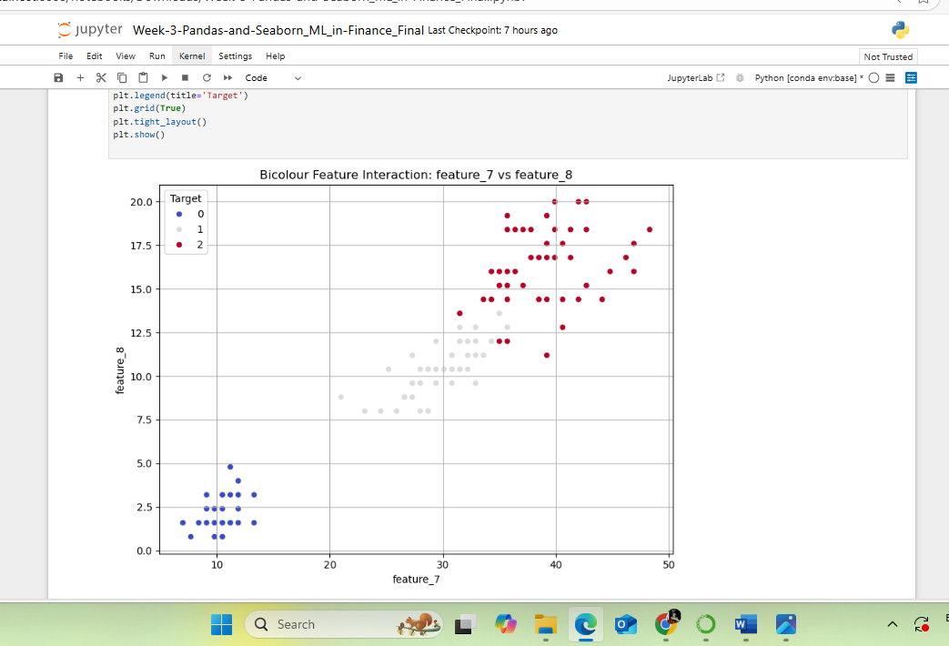

Lab 4:

import tensorflow as tf

from tensorflow import keras

from tensorflow.keras.models import Sequential

from tensorflow.keras.layers import Dense

# Make sure your datasets are already loaded and preprocessed:

# x_train, y_train, x_test, y_test

# Define the MLP model with two hidden layers

model = Sequential([

Dense(77, input_dim=x_train.shape[1], activation='relu', kernel_initializer='normal'),

Dense(38, activation='relu', kernel_initializer='normal'),

Dense(1)

])

# Compile the model (same parameters as practical session)

model.compile(optimizer='adam', loss='mse', metrics=['mae'])

# Print the architecture

print("MLP Architecture:")

model.summary()

# Train the model

history = model.fit(

x_train, y_train,

batch_size=10,

epochs=10,

validation_split=0.2,

verbose=1

)

# Evaluate on test set

test_loss, test_mae = model.evaluate(x_test, y_test)

print(f"Test MAE: {test_mae:.4f}")

**Output:**

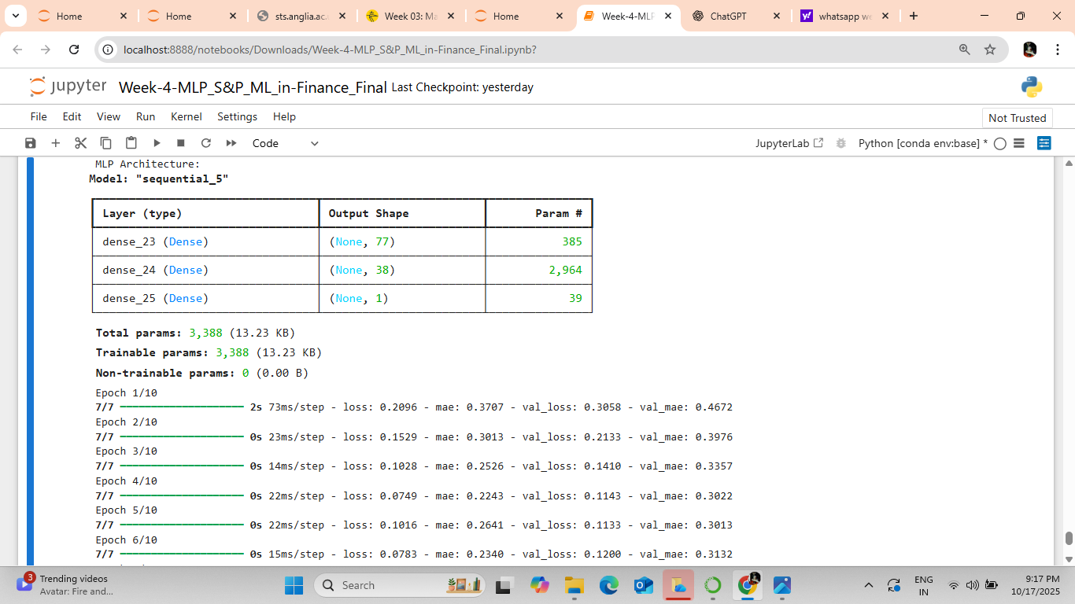

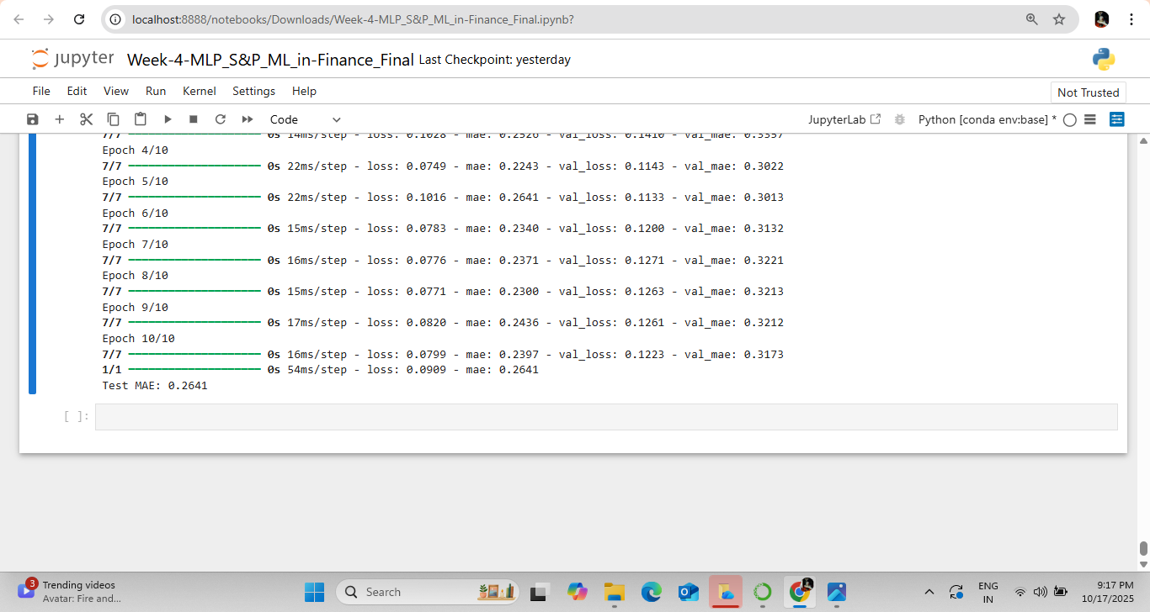

Lab 5:

import tensorflow as tf

from tensorflow import keras

from tensorflow.keras import layers

import matplotlib.pyplot as plt

# Define the CNN model with modified parameters

model = keras.Sequential([

keras.layers.Conv1D(50, 5, padding='same', input_shape=(50, 5),

activation=tf.nn.relu, kernel_initializer="normal"),

keras.layers.MaxPooling1D(7),

keras.layers.Conv1D(100, 5, padding='same',

activation=tf.nn.relu, kernel_initializer="normal"),

keras.layers.GlobalMaxPooling1D(),

keras.layers.Dense(25, activation=tf.nn.relu, kernel_initializer="normal"),

keras.layers.Dense(2) # Output: Bid and Ask

])

# Compile the model

model.compile(optimizer='adam',loss='mean_absolute_error', metrics=['mae'])

# Display model summary

print(model.summary())

# Train the model

history = model.fit(X_train, y_train,

batch_size=50, # Changed

epochs=14, # Based on your SID 2420077

validation_split=0.2,

verbose=1)

# Evaluate on test data

test_loss, test_mae = model.evaluate(X_test, y_test, verbose=1)

print(f"\nTest MAE: {test_mae:.6f}")

# Predict using trained model

pred = model.predict(X_test)

# Plot the real vs predicted values

plt.ion()

fig = plt.figure(figsize=(23, 8))

ax1 = fig.add_subplot(111)

line1, = ax1.plot(y_test[:400, 0], label='Bid')

line2, = ax1.plot(pred[:400, 0], label='Predicted Bid')

line3, = ax1.plot(y_test[:400, 1], label='Ask')

line4, = ax1.plot(pred[:400, 1], label='Predicted Ask')

plt.title('Real & Predicted Normalised Prices', size=18)

plt.ylabel('Price', size=14)

plt.xlabel('Ticks', size=14)

plt.legend(loc='upper right')

plt.show()

**Output:**

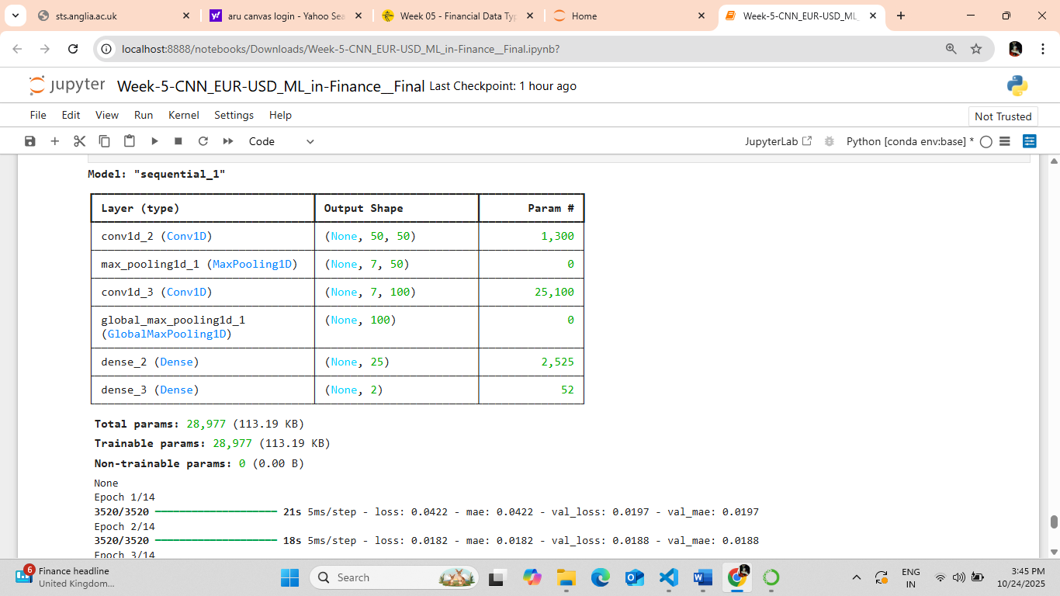

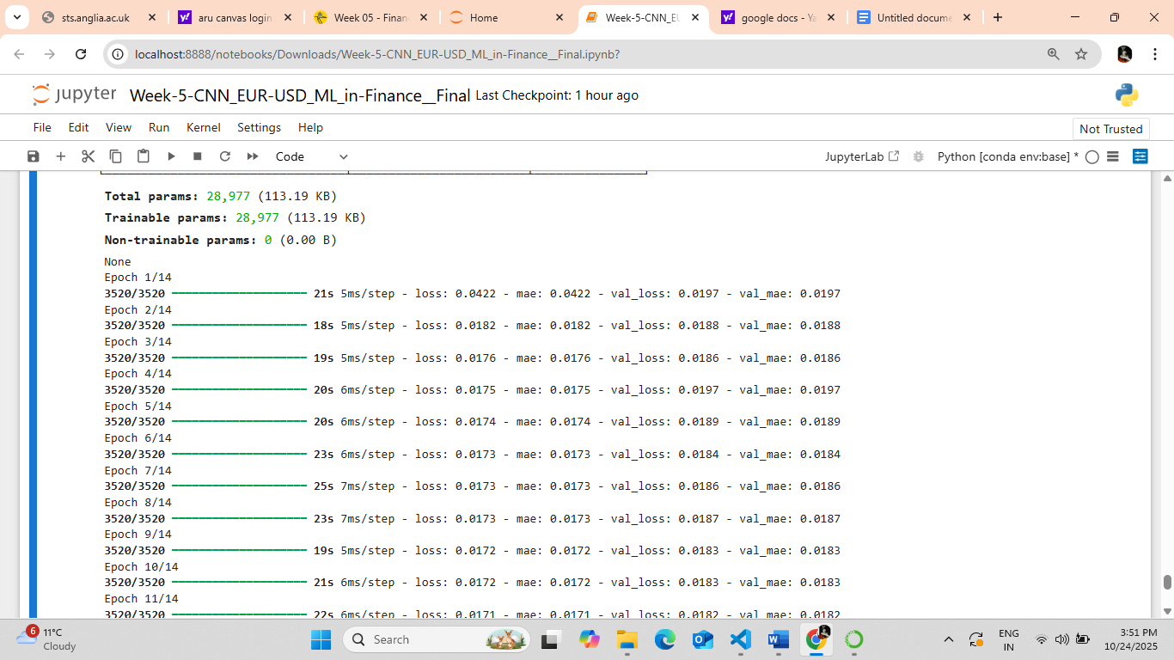

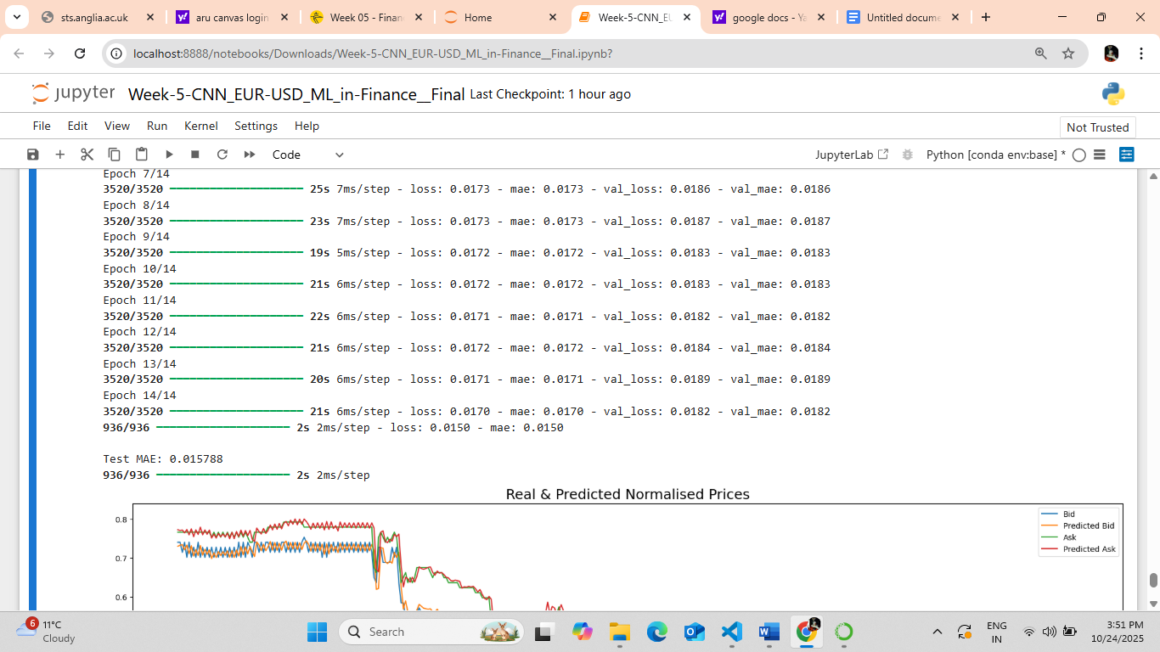

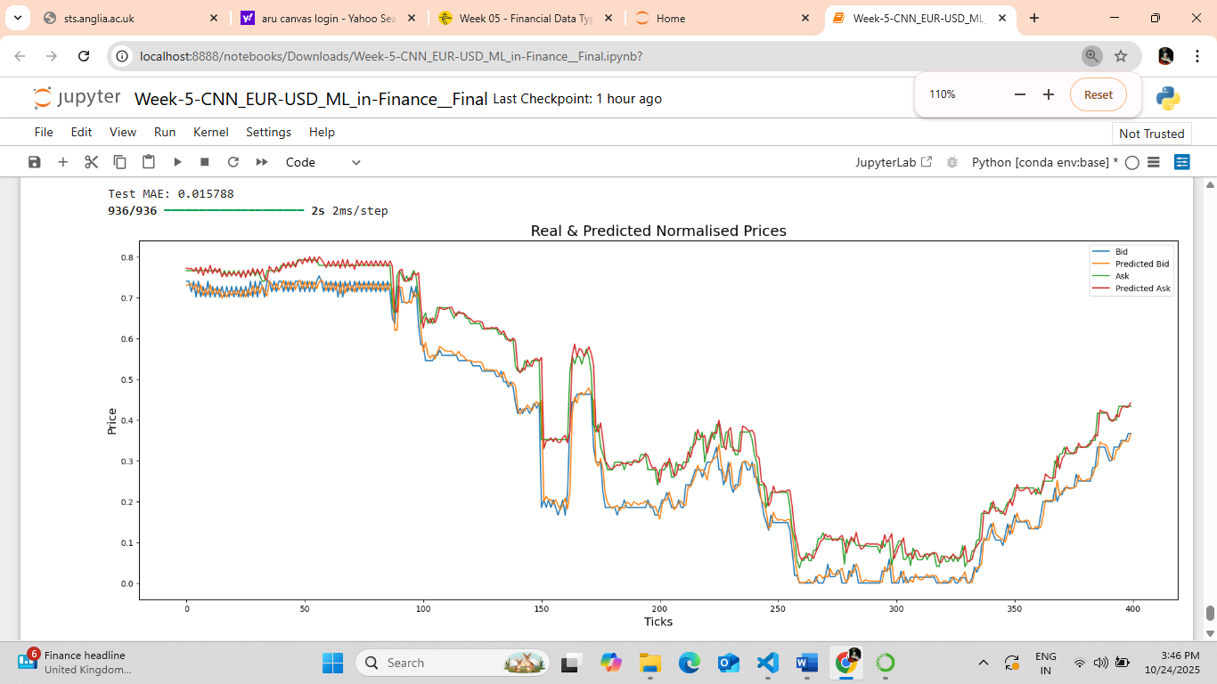

Lab 6:

# Student ID: 2420077

# Start index = 20077 (last 5 digits of SID)

# Time period = 77 minutes (last 3 digits of SID)

import pandas as pd

import cufflinks as cf

cf.go_offline()

# Load the dataset

data2 = pd.read_csv('GOLD_2022_normalised.csv')

# Convert all numeric columns properly

for col in data2.columns:

try:

data2[col] = pd.to_numeric(data2[col])

except:

pass

# Select only numeric columns

numeric_cols = data2.select_dtypes(include='number').columns

# Normalise numeric columns

min_price = data2[numeric_cols].min().min()

max_price = data2[numeric_cols].max().max()

data2[numeric_cols] = (data2[numeric_cols] - min_price) / (max_price - min_price)

# Select dataset part based on Student ID

start_index = 20077

period = 77

data_part = data2.iloc[start_index : start_index + period]

# Rename columns for clarity (if necessary)

data_part.rename(columns={'High_x': 'High_Bid', 'Low_x': 'Low_Bid'}, inplace=True)

# Plot the chart

data_part[['High_Bid', 'Low_Bid']].iplot(

title='GOLD Price Chart (High_Bid vs Low_Bid) - Student ID: 2420077',

xTitle='Time (UTC)',

yTitle='Normalized Price',

theme='solar'

)

**Output:**

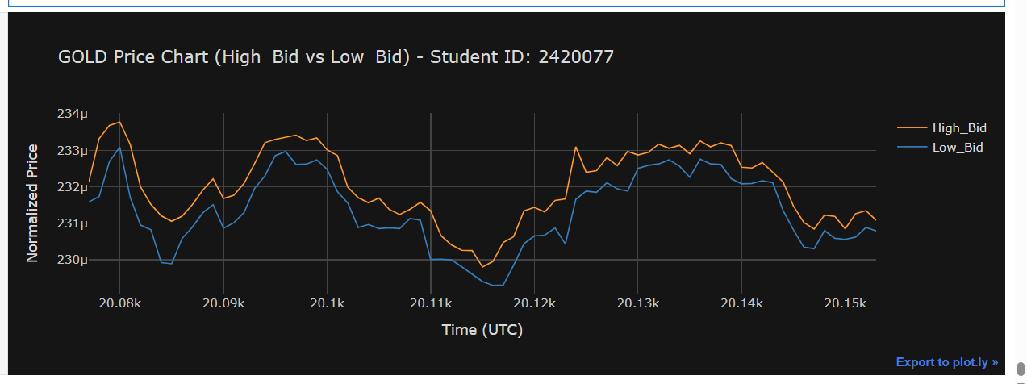

Lab 7:

import numpy as np

import pandas as pd

from tensorflow.keras.models import Sequential

from tensorflow.keras.layers import LSTM, Dense

from tensorflow.keras.callbacks import EarlyStopping

from sklearn.preprocessing import MinMaxScaler

from sklearn.metrics import mean_squared_error, mean_absolute_error

import matplotlib.pyplot as plt

# ------------------------------

# Load and preprocess your dataset

# ------------------------------

data = pd.read_csv('GOLD_2022_normalised_NEW-1000.csv')

# Select the target column (change to 'Close_Ask' if needed)

values = data['Close_Bid'].values.reshape(-1, 1)

scaler = MinMaxScaler()

scaled_values = scaler.fit_transform(values)

# Create your train-test split

train_size = int(len(scaled_values) * 0.8)

train, test = scaled_values[:train_size], scaled_values[train_size:]

# Function to create sequences

def create_dataset(dataset, time_step=1):

X, Y = [], []

for i in range(len(dataset) - time_step - 1):

X.append(dataset[i:(i + time_step), 0])

Y.append(dataset[i + time_step, 0])

return np.array(X), np.array(Y)

time_step = 10

X_train, y_train = create_dataset(train, time_step)

X_test, y_test = create_dataset(test, time_step)

# Reshape input to [samples, time steps, features]

X_train = X_train.reshape(X_train.shape[0], X_train.shape[1], 1)

X_test = X_test.reshape(X_test.shape[0], X_test.shape[1], 1)

# ------------------------------

# Build the LSTM model

# ------------------------------

model = Sequential()

model.add(LSTM(87, input_shape=(time_step, 1))) # SID 2420077 → 77+10=87

model.add(Dense(1))

model.compile(optimizer='adam', loss='mse', metrics=['mae'])

# Show model summary for screenshot

model.summary()

# ------------------------------

# Train the model

# ------------------------------

early_stop = EarlyStopping(monitor='val_loss', patience=3, restore_best_weights=True)

history = model.fit(

X_train, y_train,

validation_data=(X_test, y_test),

epochs=10, # Changed to 10

batch_size=32,

verbose=1,

callbacks=[early_stop]

)

# ------------------------------

# Evaluate the model

# ------------------------------

y_pred = model.predict(X_test)

y_pred_rescaled = scaler.inverse_transform(y_pred)

y_test_rescaled = scaler.inverse_transform(y_test.reshape(-1, 1))

test_mse = mean_squared_error(y_test_rescaled, y_pred_rescaled)

test_mae = mean_absolute_error(y_test_rescaled, y_pred_rescaled)

print(f"Test MSE: {test_mse:.4f}")

print(f"Test MAE: {test_mae:.4f}")

# ------------------------------

# Plot MAE graph

# ------------------------------

plt.figure(figsize=(8,5))

plt.plot(history.history['mae'], label='Train MAE')

plt.plot(history.history['val_mae'], label='Validation MAE')

plt.title('LSTM Model MAE over Epochs')

plt.xlabel('Epochs')

plt.ylabel('MAE')

plt.legend()

plt.show()

**Output:**

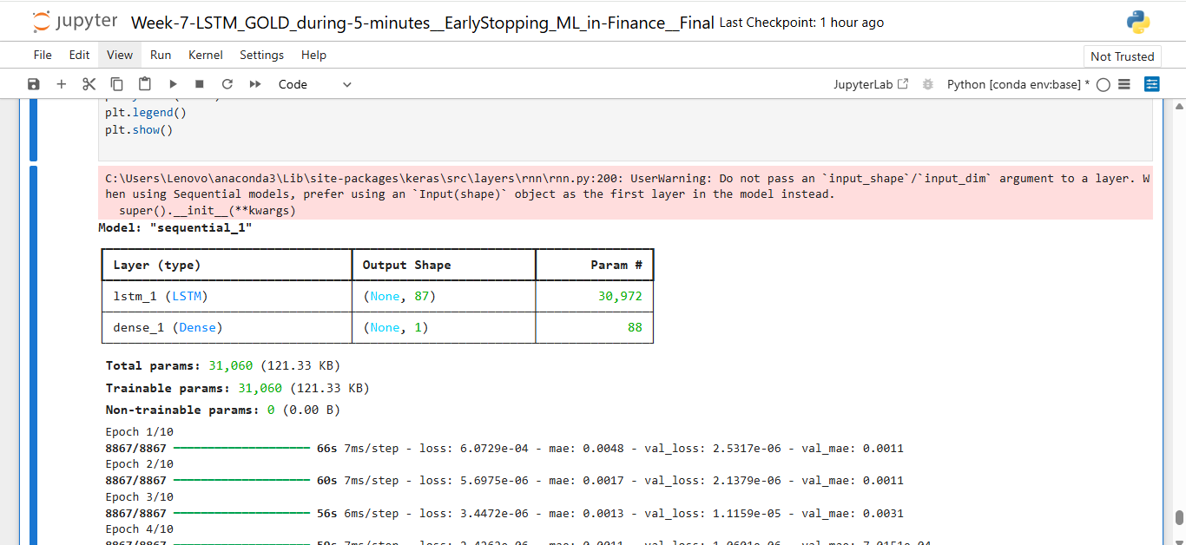

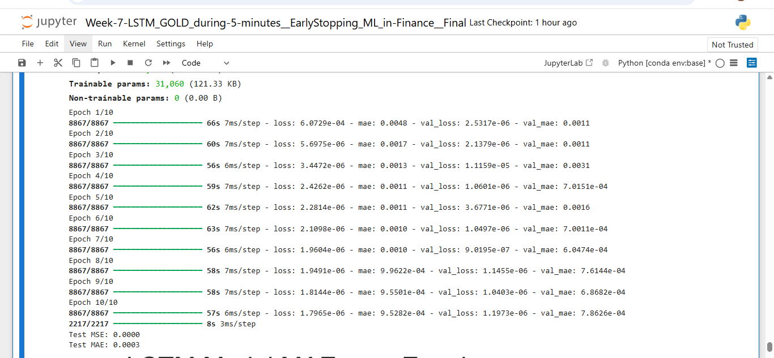

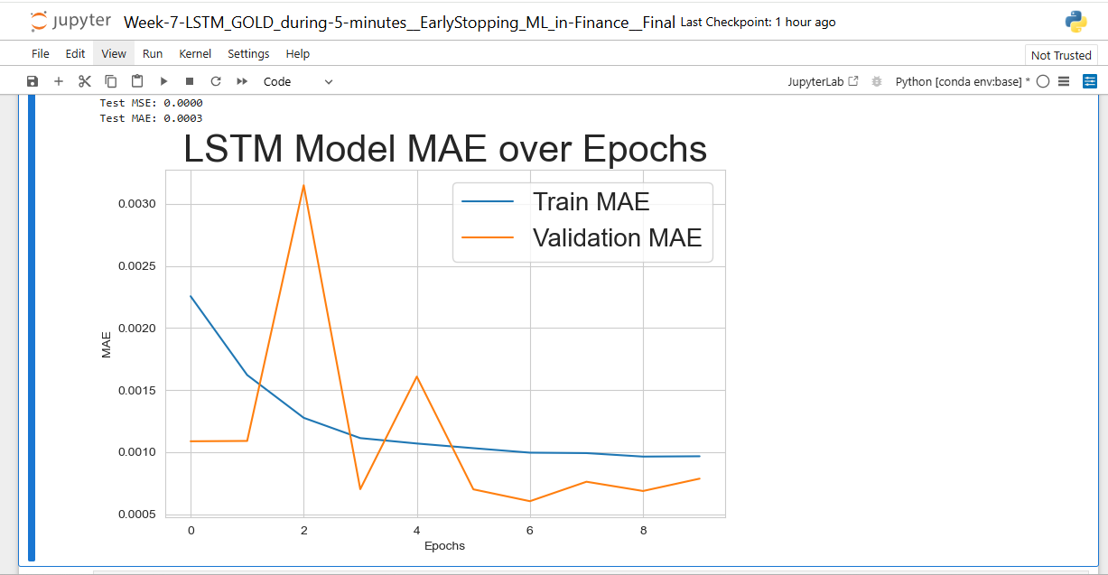

Lab 8:

CNN:

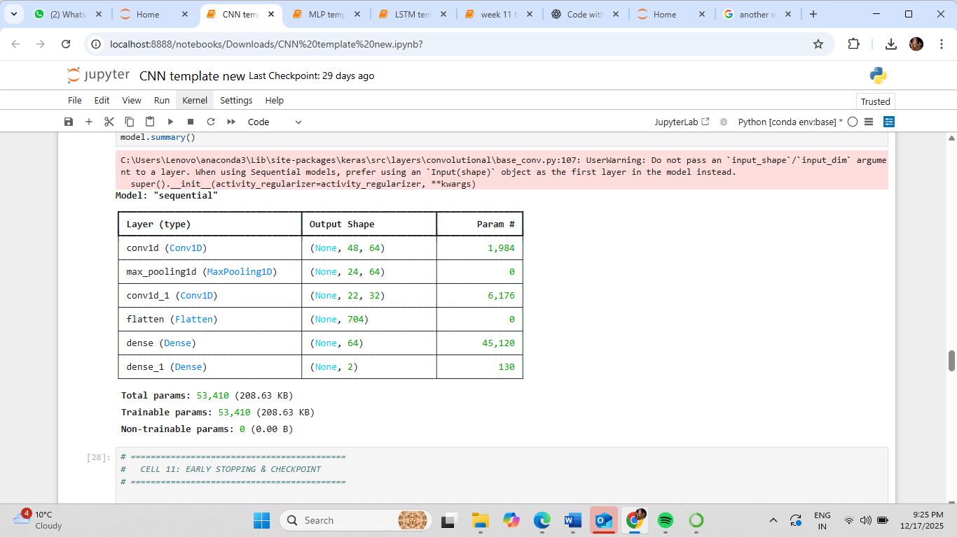

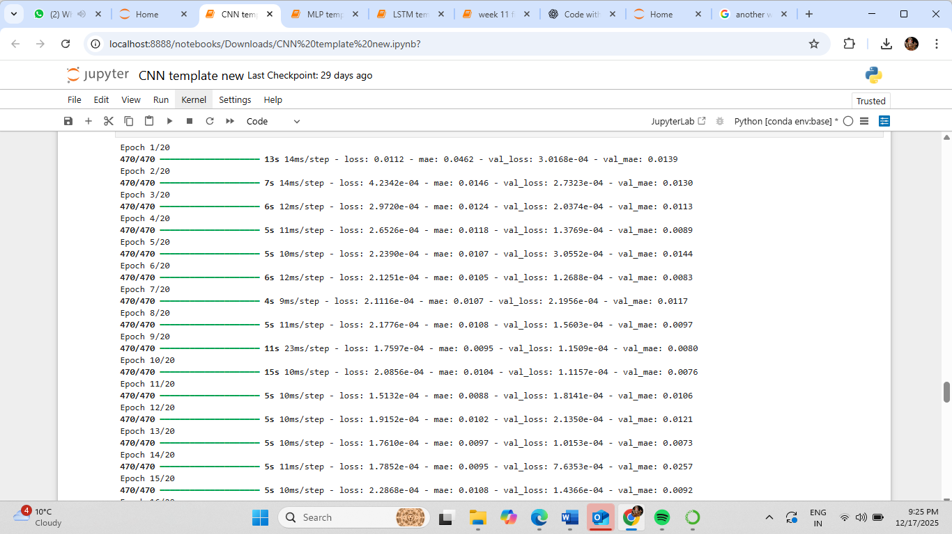

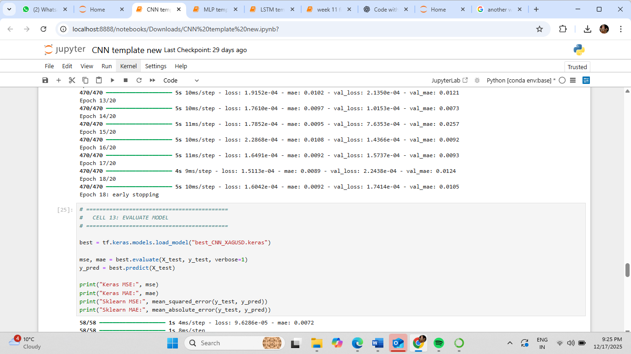

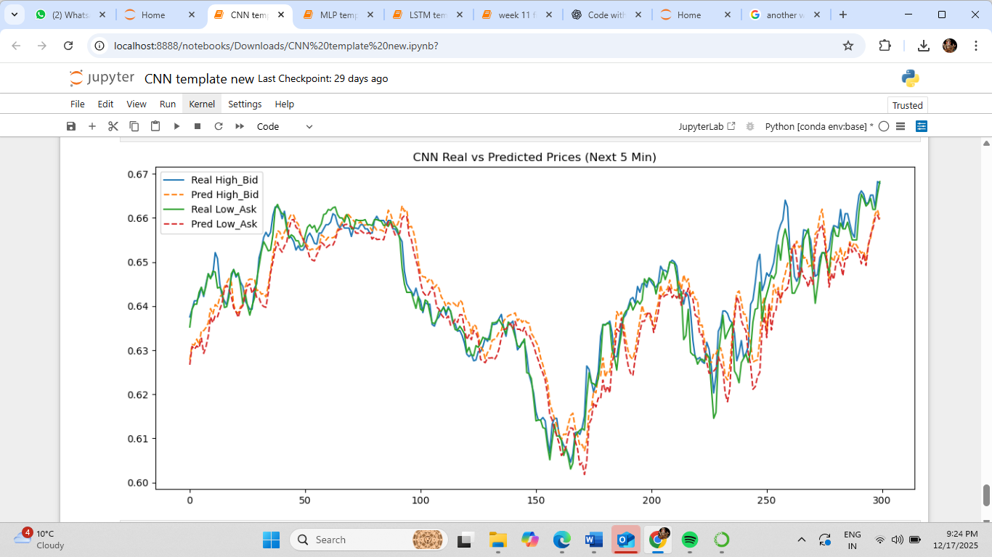

MLP:

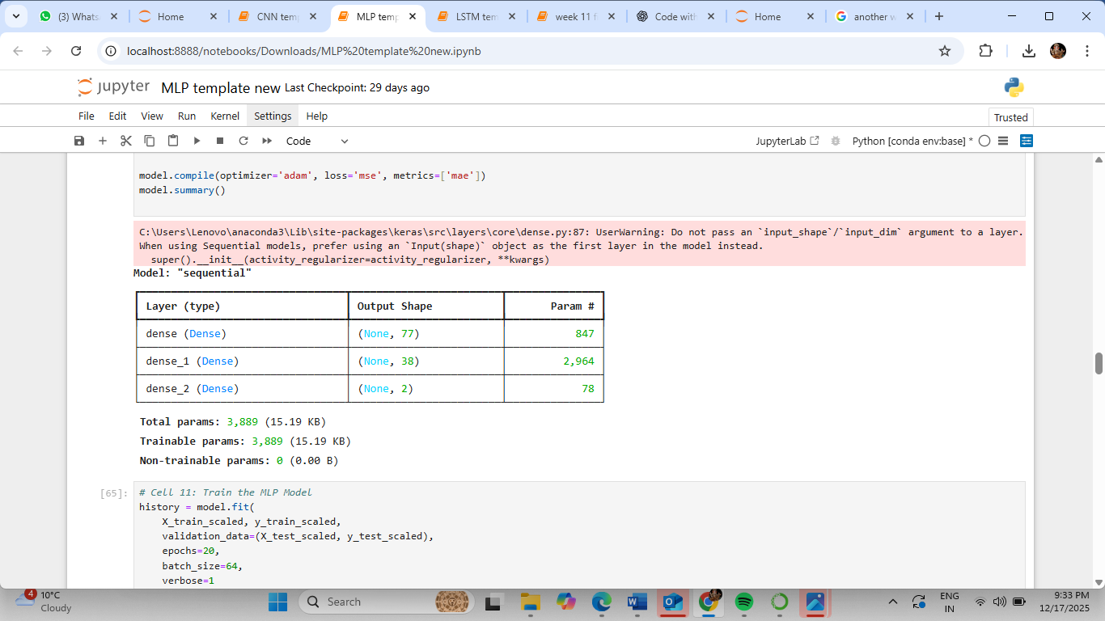

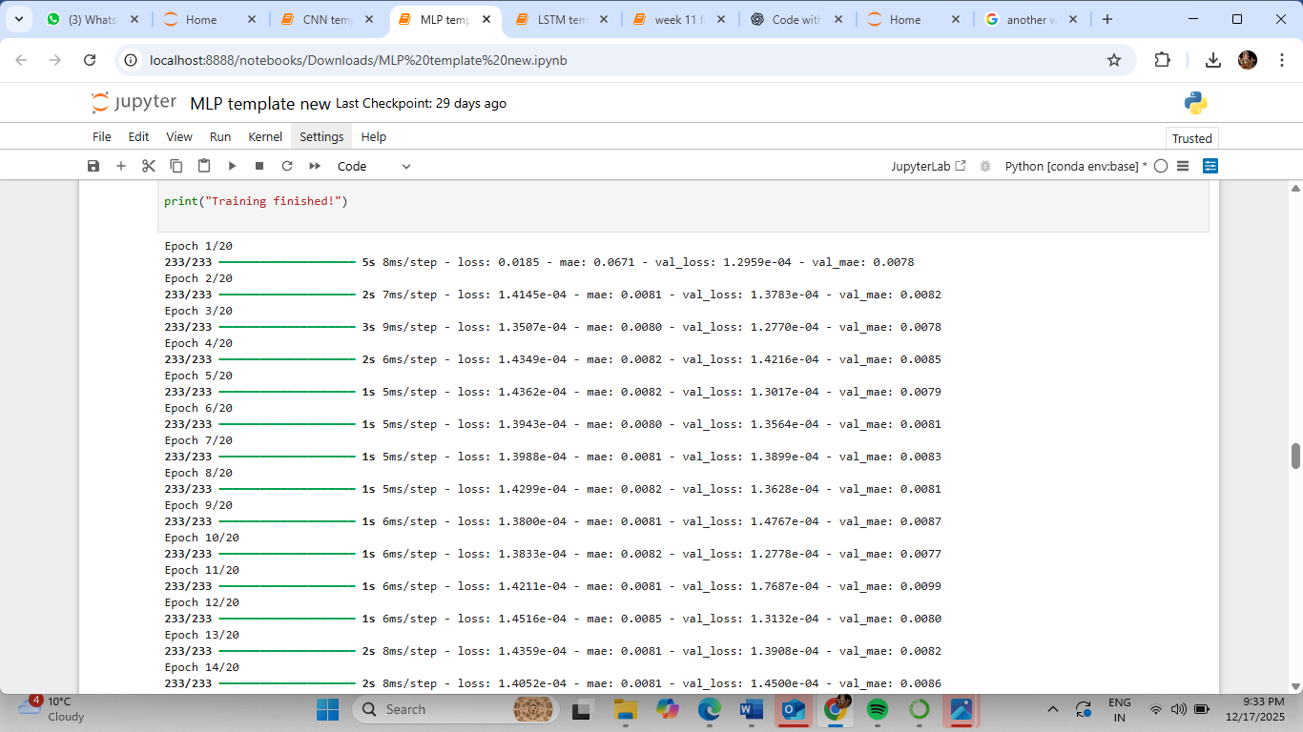

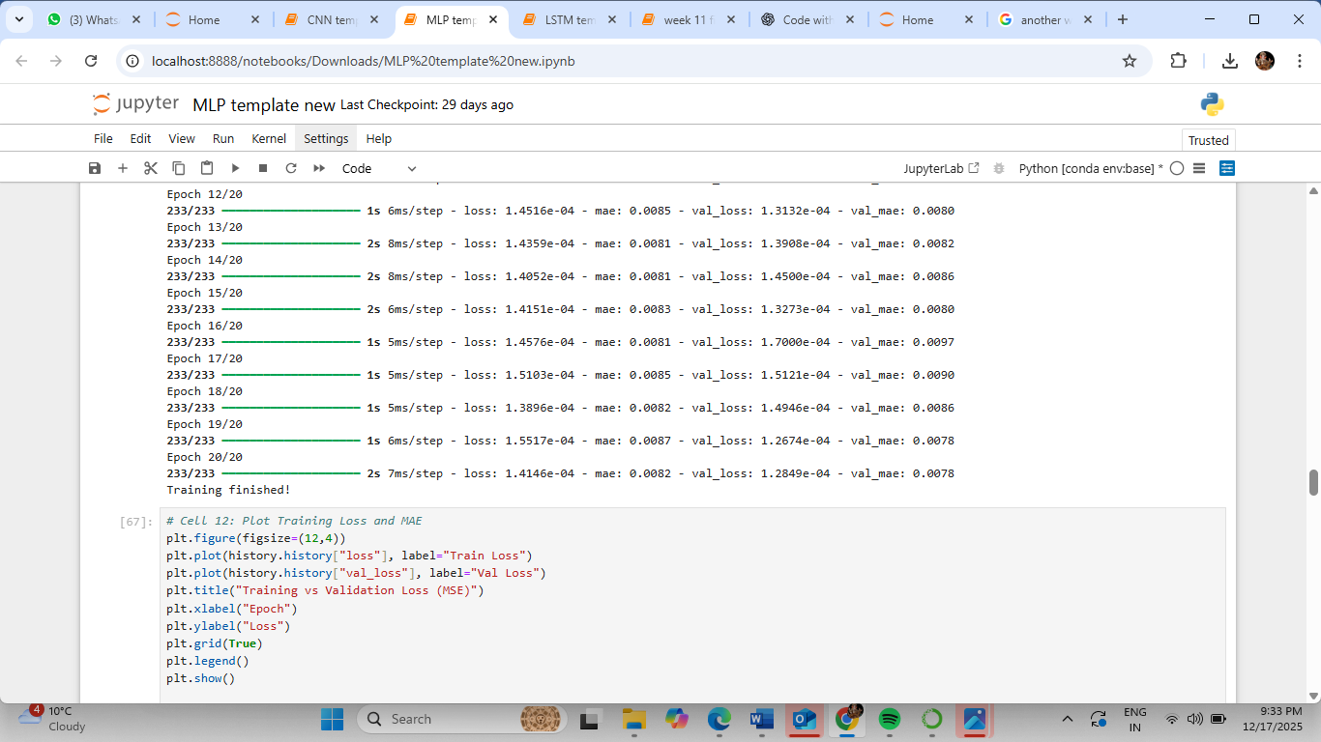

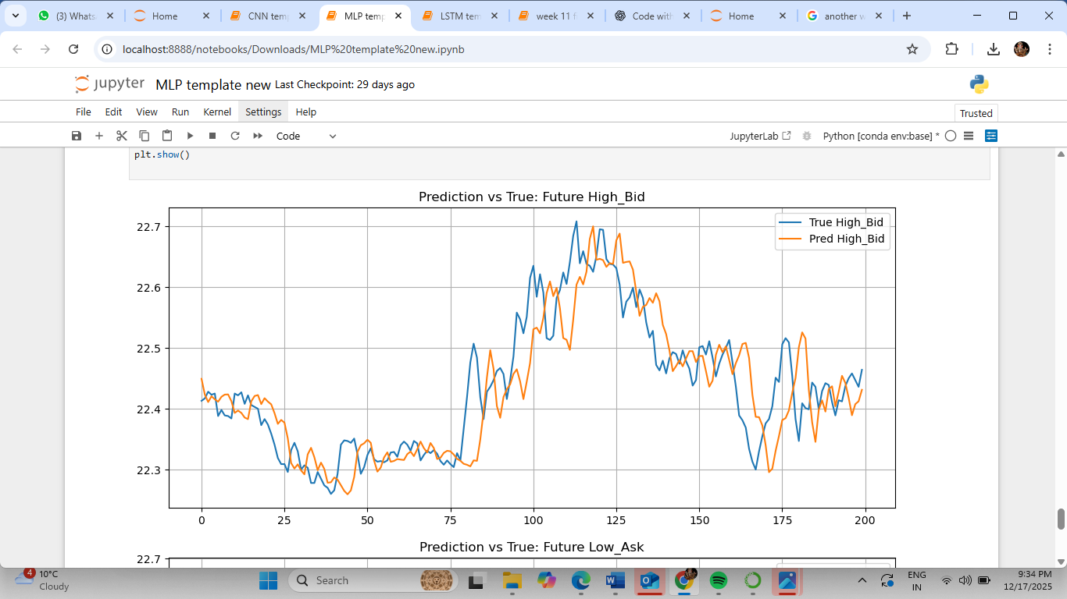

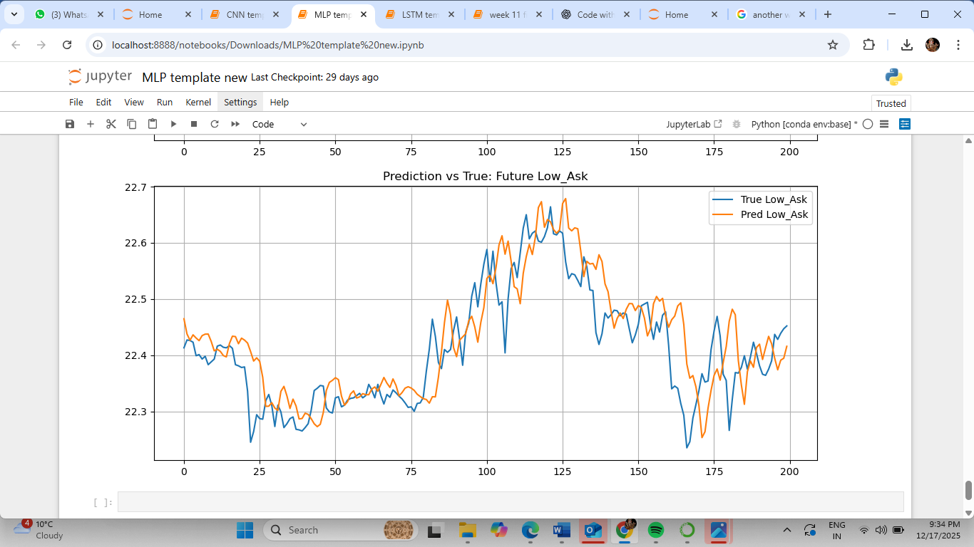

LSTM:

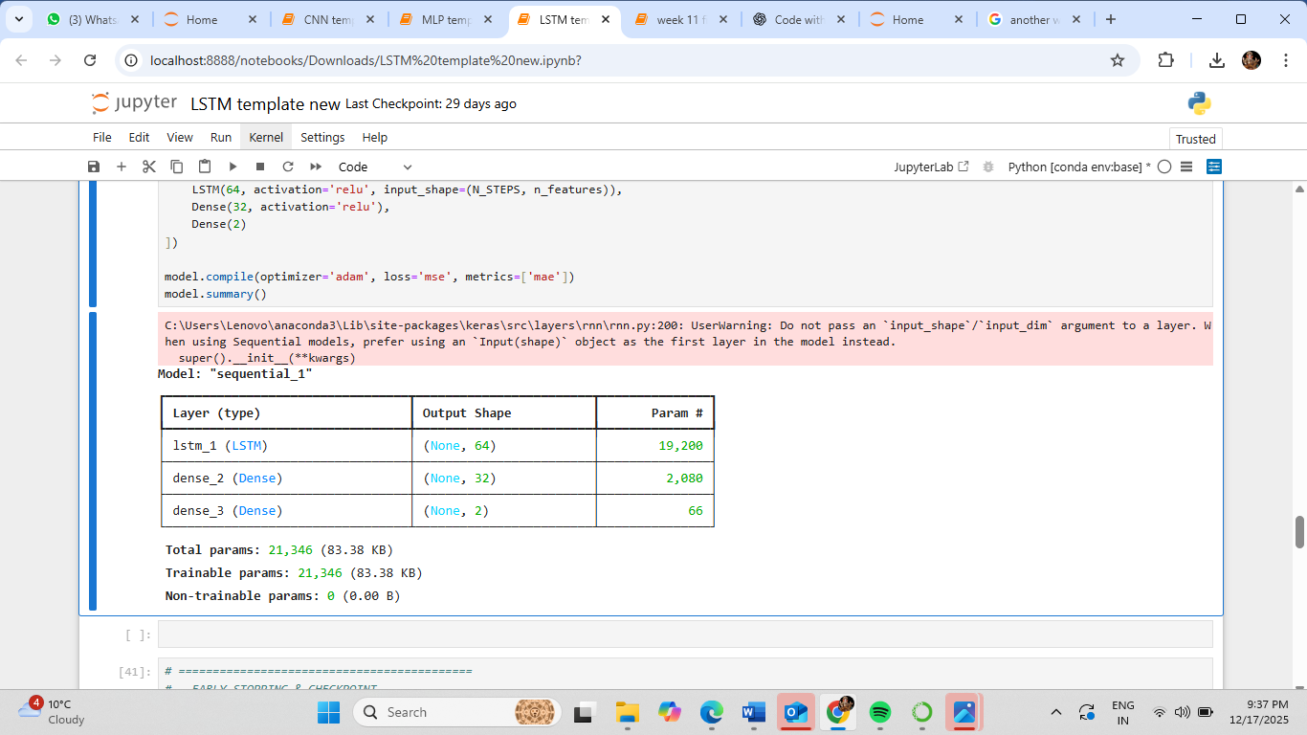

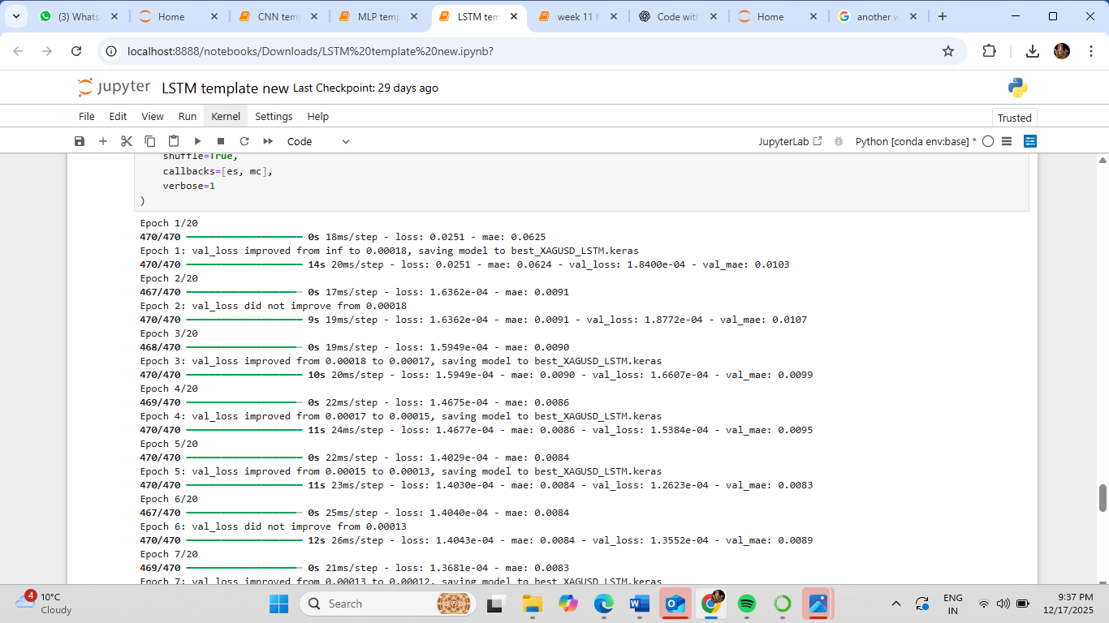

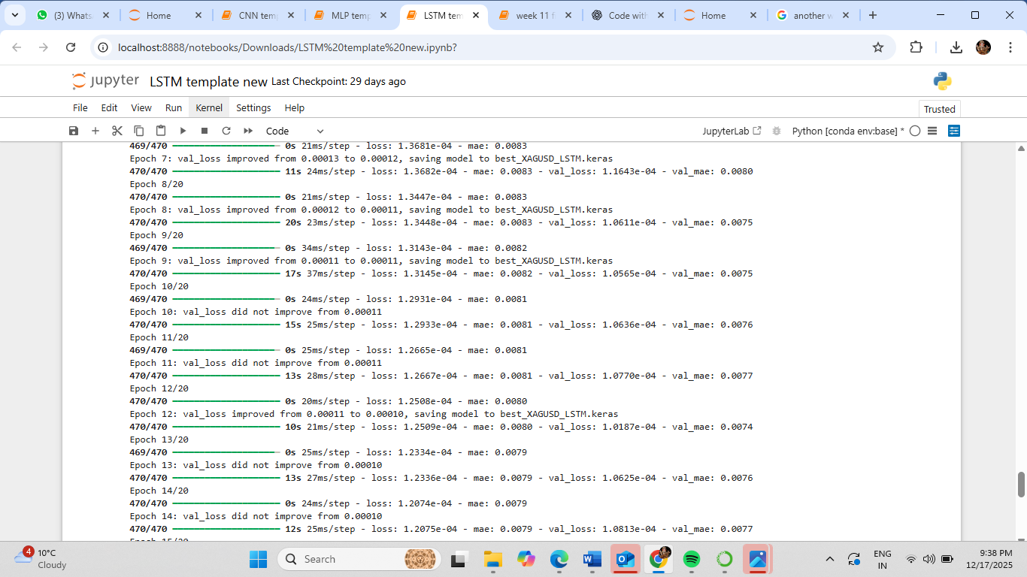

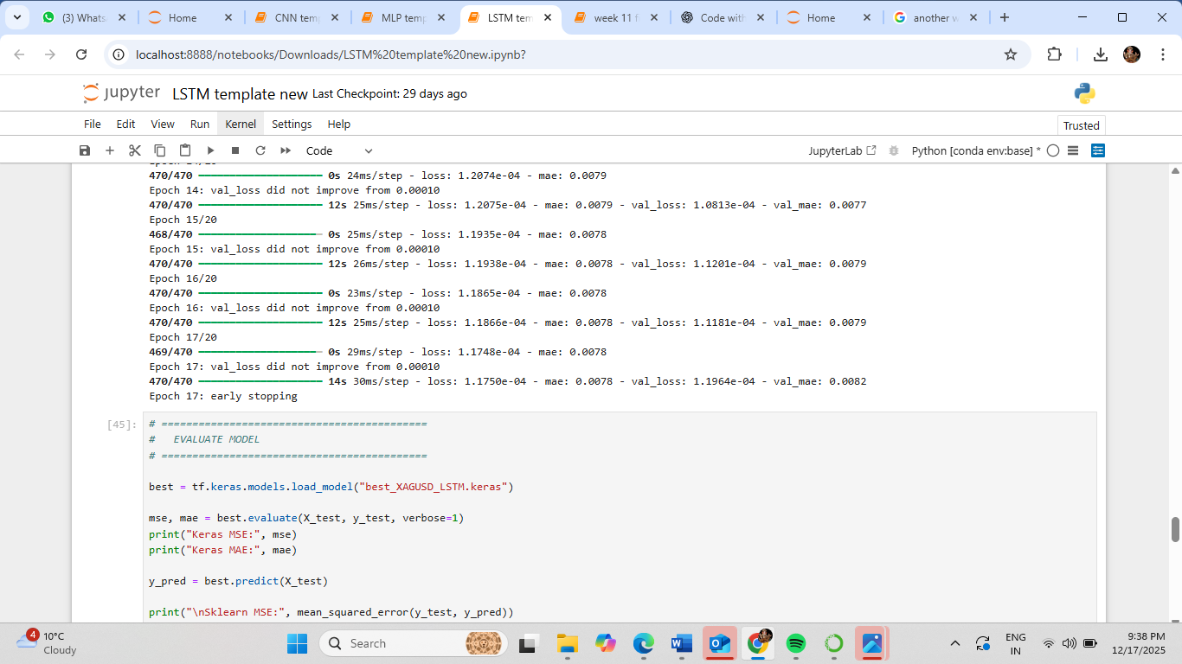

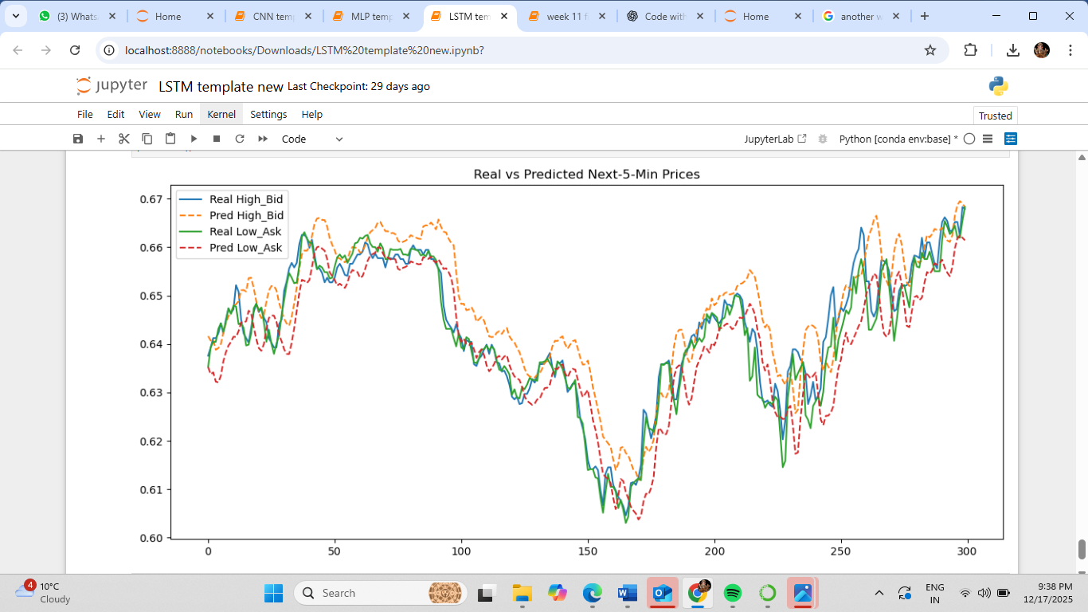

Lab 9 :

In class test

Lab 10:

# SID: 2420077

# batch_size = 17

# epochs = 37

from tensorflow.keras.callbacks import EarlyStopping, ModelCheckpoint

es = EarlyStopping(monitor='val_loss', mode='min', verbose=1, patience=10)

mc = ModelCheckpoint(

'best_Trand-Flat_model_LSTM_GOLD_2420077.keras',

monitor='val_loss',

mode='min',

verbose=1,

save_best_only=True

)

history = model.fit(

X_train,

y_train,

batch_size=17,

epochs=37,

validation_split=0.2,

shuffle=True,

verbose=1,

callbacks=[es, mc],

class_weight=class_weight_dict

)

pred = LSTM_saved_best_model.predict(X_test)

pred_binary = (pred >= 0.6).astype(int)

from sklearn.metrics import classification_report

error_metrics_report = classification_report(y_test, pred_binary)

print("Test Accuracy and Error Metrics:")

print(error_metrics_report)

import matplotlib.pyplot as plt

plt.figure(figsize=(12, 6))

plt.plot(history.history['accuracy'], label='Training Accuracy', marker='o', linewidth=2)

plt.plot(history.history['val_accuracy'], label='Validation Accuracy', marker='s', linewidth=2)

plt.title(

'More Detailed Accuracy - Training vs Validation (Modified Parameters)',

fontsize=14,

fontweight='bold'

)

plt.xlabel('Epoch', fontsize=12)

plt.ylabel('Accuracy', fontsize=12)

plt.legend(loc='best', fontsize=11)

plt.grid(True, alpha=0.3)

plt.tight_layout()

plt.show()

**output:**

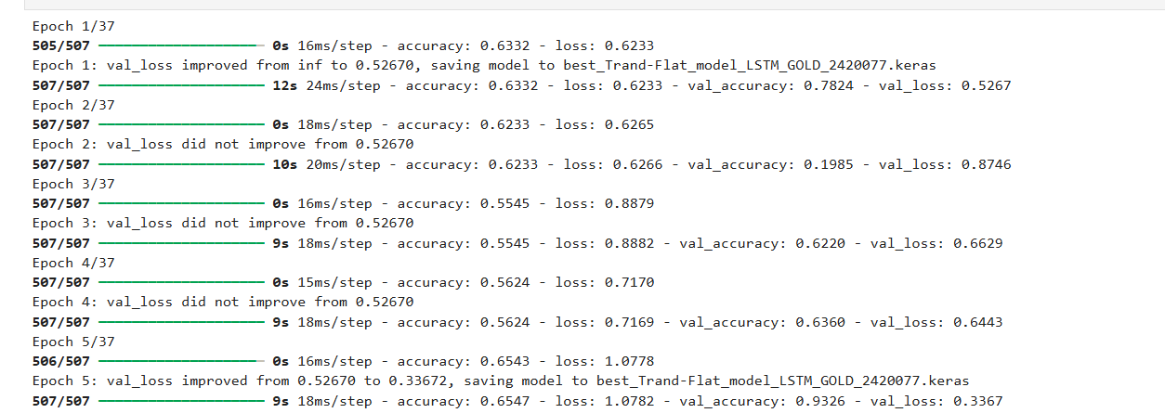

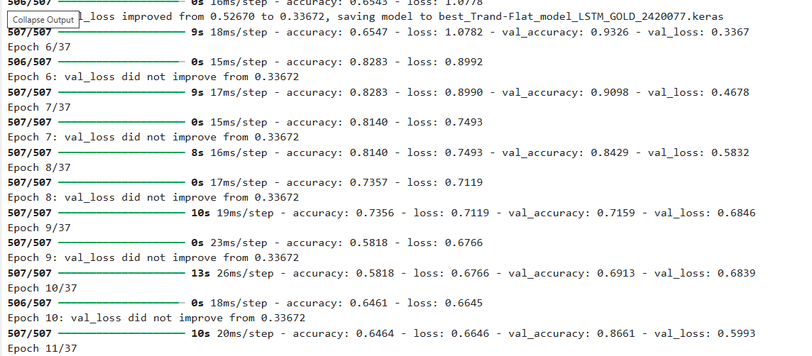

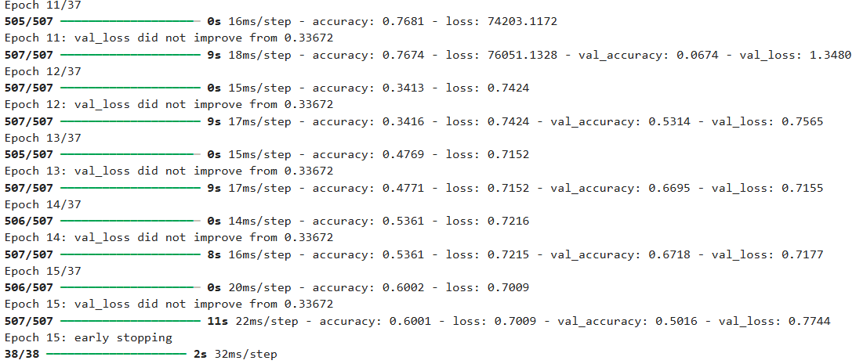

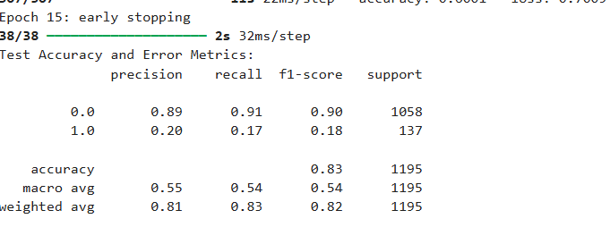

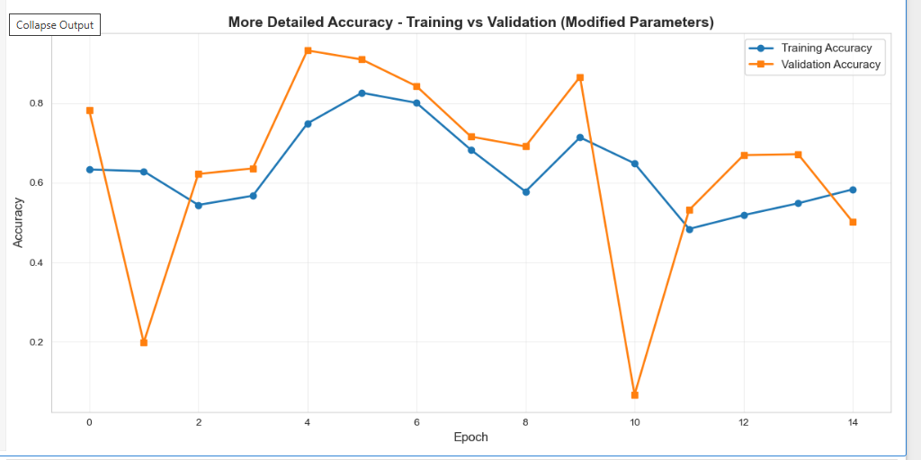

Lab 11:

# ============================================

# Cell 7

# Create and train YOUR OWN LSTM model

# SID: 2420077 → Z = 7

# epochs = 37

# batch_size = 17

# ============================================

import tensorflow as tf

from tensorflow.keras.models import Sequential

from tensorflow.keras.layers import LSTM, Dense, Dropout, BatchNormalization

from tensorflow.keras.callbacks import EarlyStopping, ModelCheckpoint

EPOCHS = 37

BATCH_SIZE = 17

lstm_model = Sequential([

LSTM(128, input_shape=(1, n_features), return_sequences=True),

BatchNormalization(),

Dropout(0.25),

LSTM(64, return_sequences=False),

BatchNormalization(),

Dropout(0.25),

Dense(32, activation='relu'),

Dropout(0.15),

Dense(1, activation='sigmoid')

])

lstm_model.compile(

optimizer=tf.keras.optimizers.Adam(learning_rate=0.001),

loss='binary_crossentropy',

metrics=['accuracy']

)

es = EarlyStopping(

monitor='val_loss',

mode='min',

patience=10,

restore_best_weights=True,

verbose=1

)

mc = ModelCheckpoint(

'best_LSTM_2420077.keras',

monitor='val_loss',

mode='min',

save_best_only=True,

verbose=1

)

history = lstm_model.fit(

X_train_lstm,

y_train,

epochs=EPOCHS,

batch_size=BATCH_SIZE,

validation_split=0.2,

shuffle=True,

callbacks=[es, mc],

verbose=1

)

**Output:**

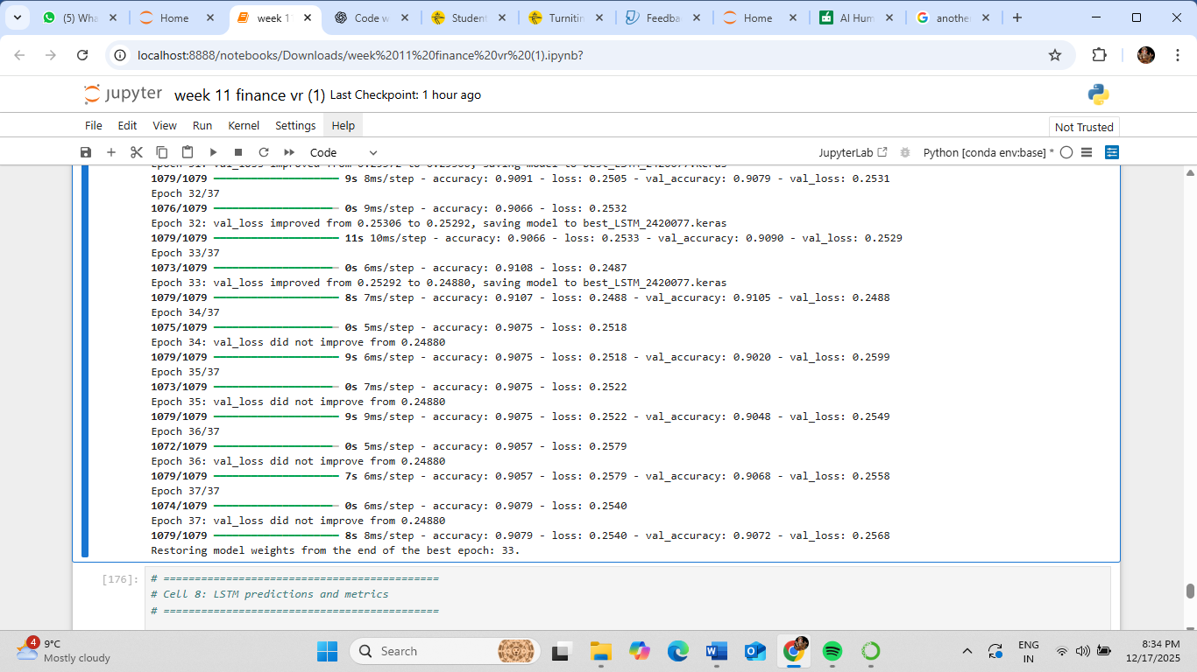



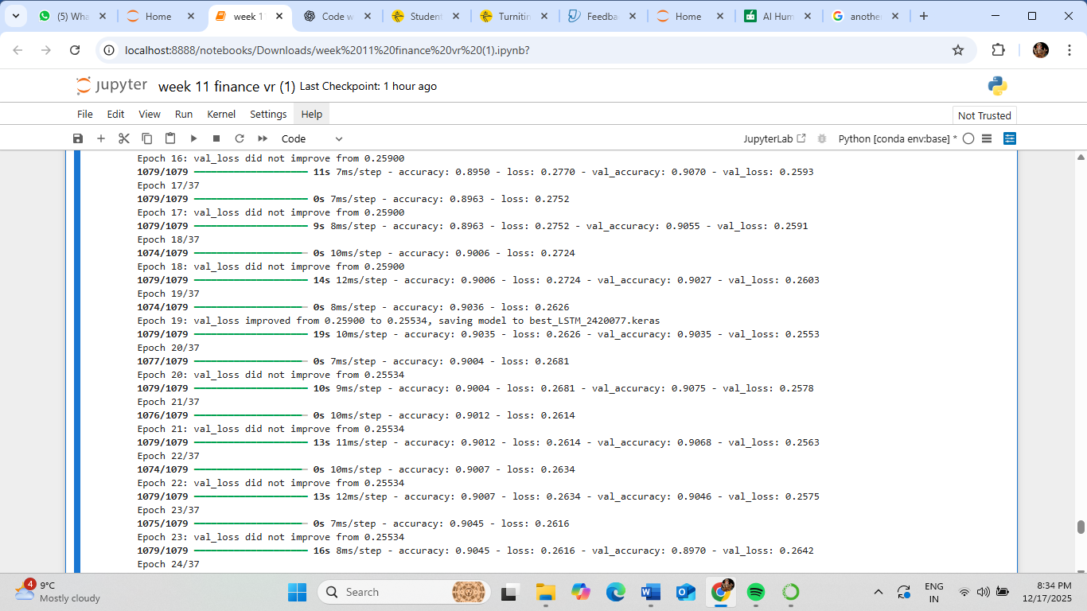

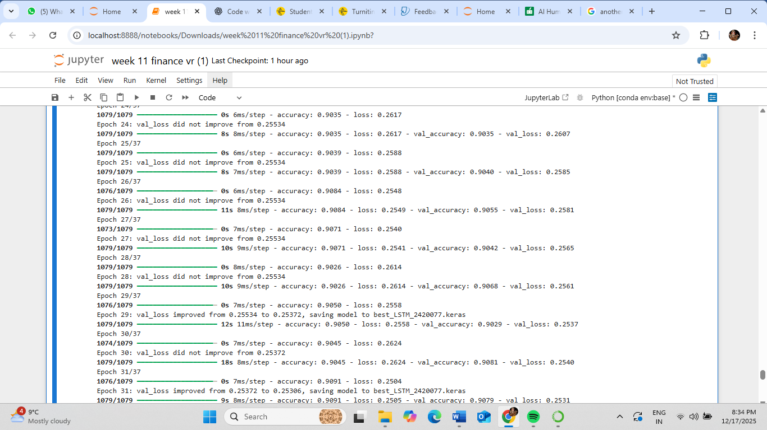

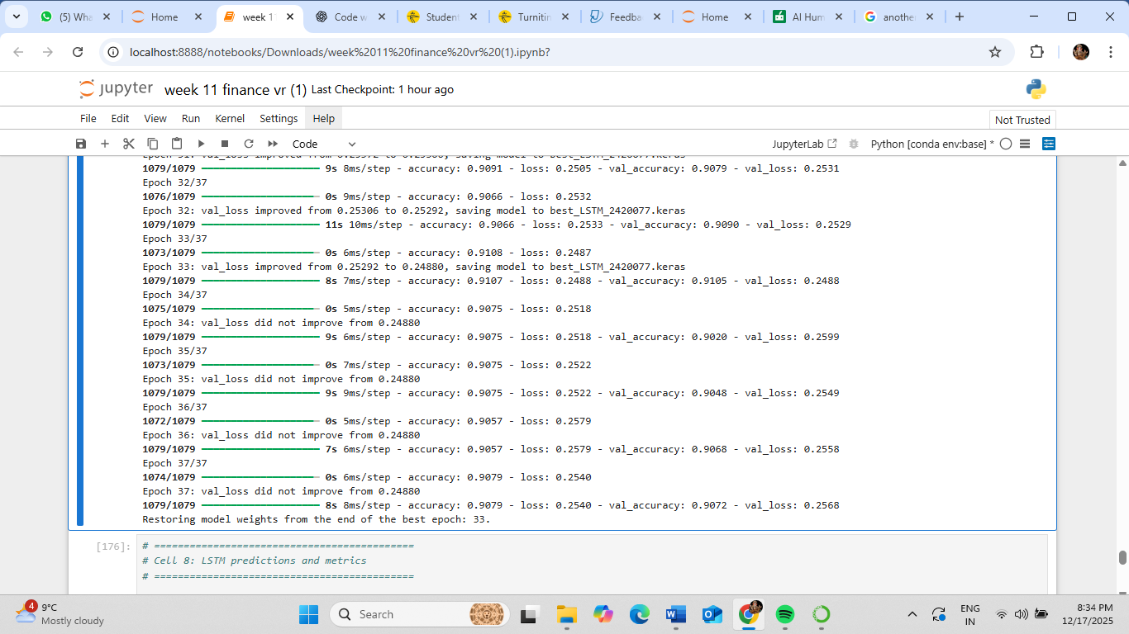

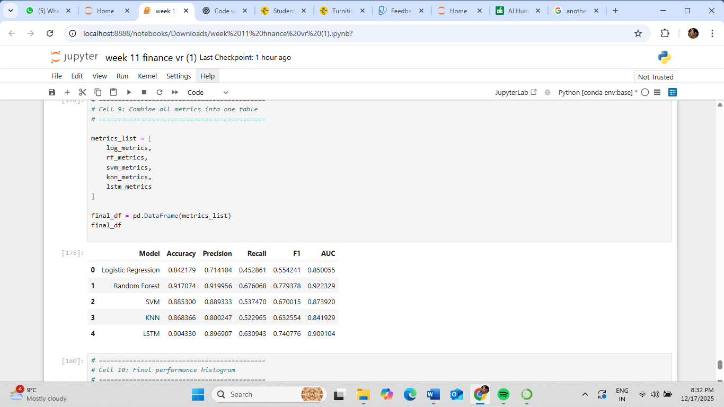

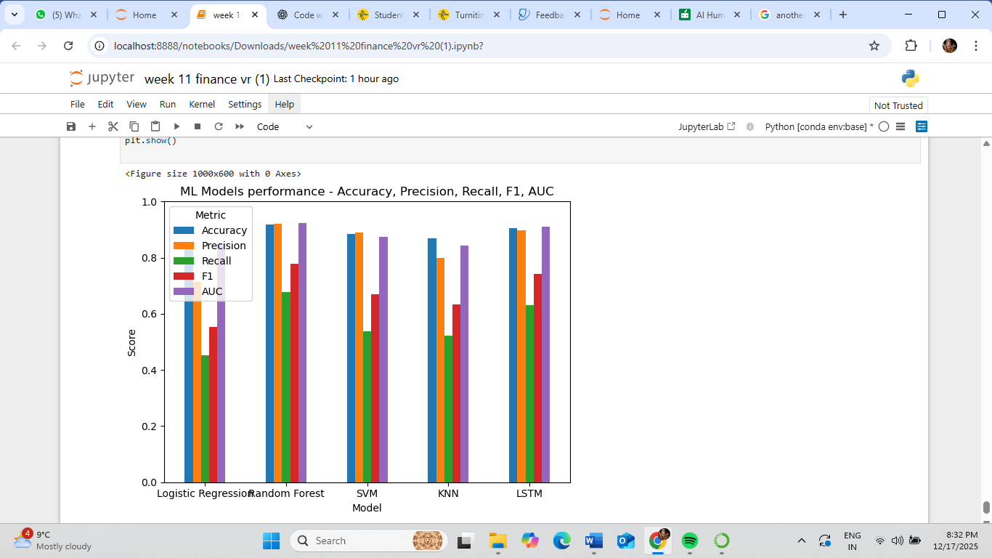

Lab 12:

Final code with report